**USING LOOP IN LOOP**

1. Please write code to display like this.

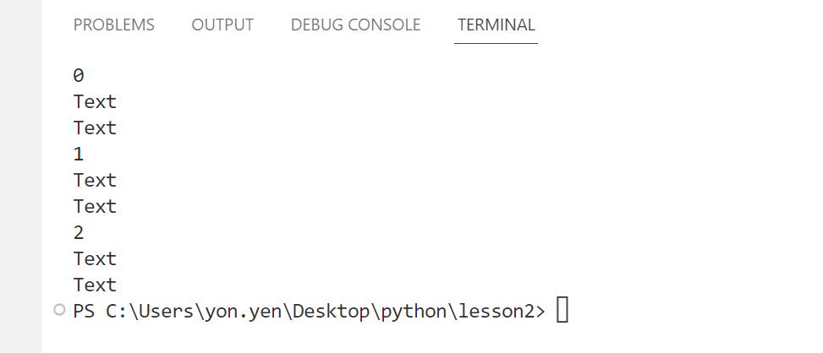

for i in range(3):

    print(i)

    for n in range(2):

        print("text")

1. Please write code to display like this.

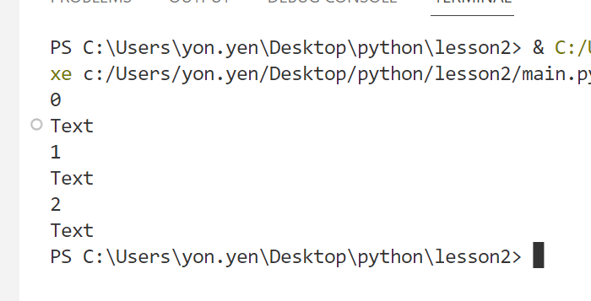

1, for i in range(3):

    print(i)

    for n in range(1):

        print("text")

for i in range(3):

    print(i)

    print("text")

1. Please write code to display like this.

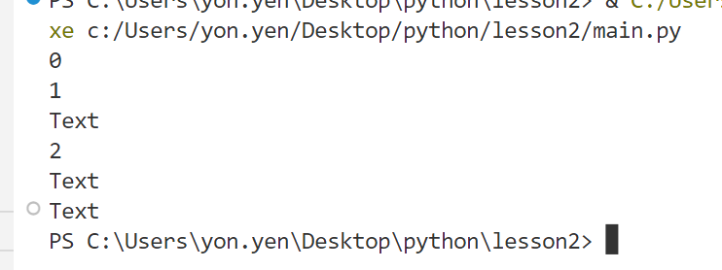

for i in range(3):

    print(i)

    for n in range(i):

        print("text")

1. Please write code to display like this.

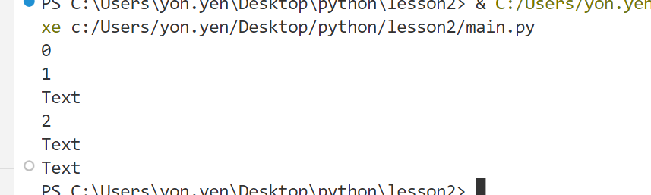

for i in range(3):

    print(i)

    for n in range(i):

        print("text")

1. Please write code to display like this.

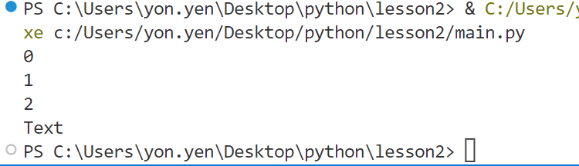

for i in range(3):

    print(i)

    for n in range(i-1):

        print("text")

1. Please write code to display like this.

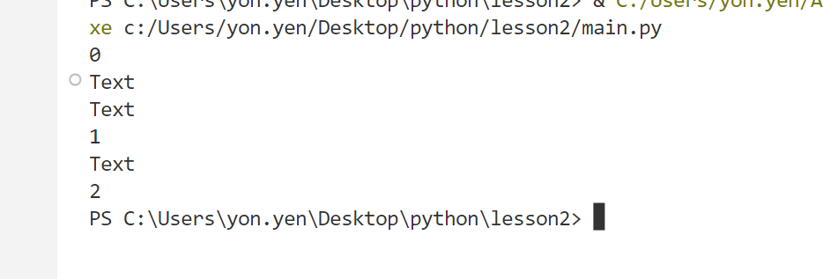

for i in range(3):

    print(i)

    for n in range(2-i):

        print("text")

n

1. Please write code to display like this.

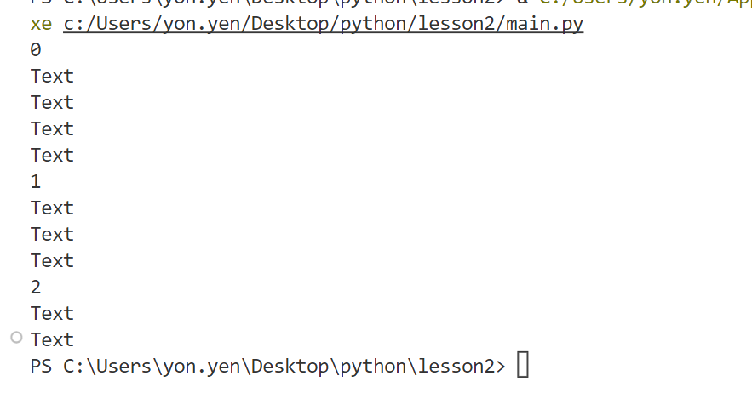

for i in range(3):

    print(i)

    for n in range(4-i):

        print("text")

1. Please write code

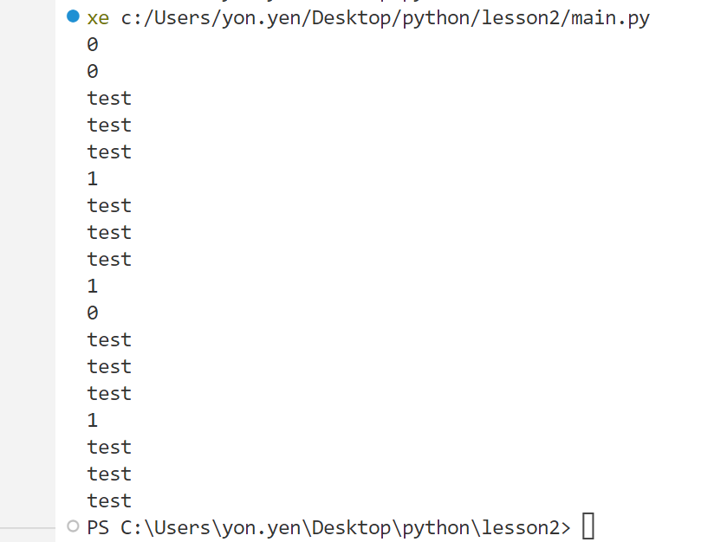

for i in range(2):

    print(i)

    for i in range(2):

        print(i)

        for m in range(3):

            print("test")

1. Please write

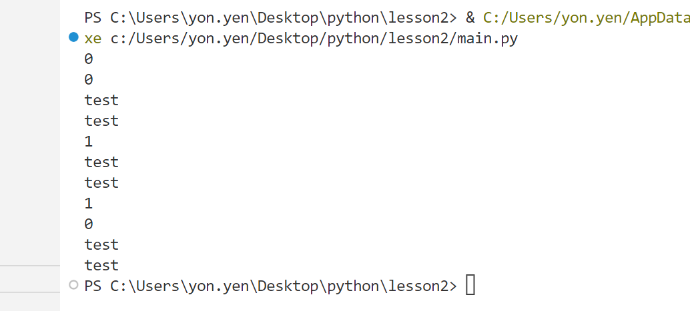

for i in range(2):

    print(i)

    for i in range(2-i):

        print(i)

        for m in range(2):

            print("test")

1. Please write code.

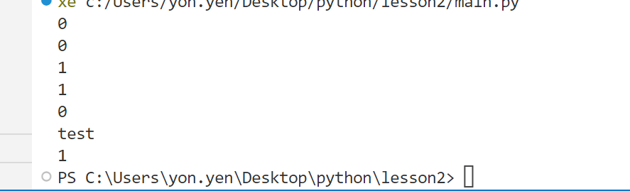

for n in range(2):

    print(n)

    for m in range(2-n):

        print(m)

        for o in range(n-m):

            print("text")

1. Please

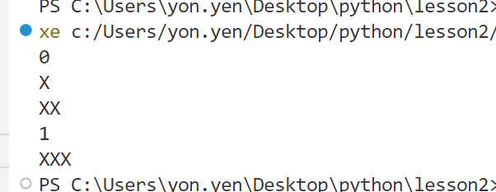

text=""

for n in range(2):

    print(n)

    for m in range(2-n):

        text=text+"x"

        print(text)

1. Please

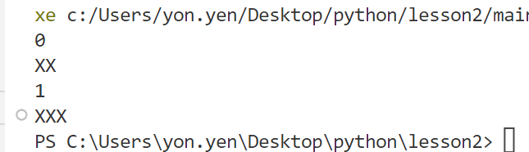

text=""

for n in range(2):

    print(n)

    for m in range(2-n):

        text=text+"x"

    print(text)

1. Please

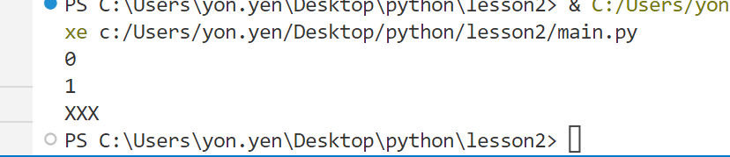

text=""

for n in range(2):

    print(n)

    for m in range(2):

        text=text+"x"

print(text)

1. Please

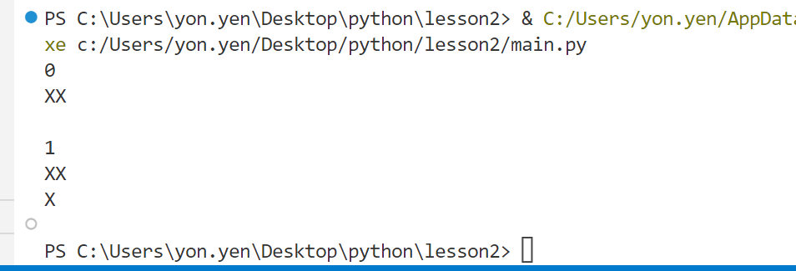

for n in range(2):

    print(n)

    for m in range(2-n):

        text=text+"x"

    text=text+"\n"

    print(text)

1. Please

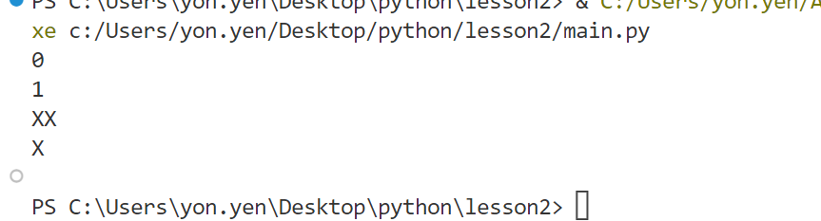

text=""

for n in range(2):

    print(n)

    for m in range(2-n):

        text=text+"x"

    text=text+"\n"

print(text)

1. Please

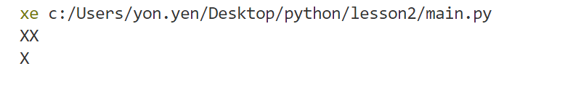

text=""

for n in range(2):

    for m in range(2-n):

        text=text+"x"

    text=text+"\n"

print(text)

1. Please

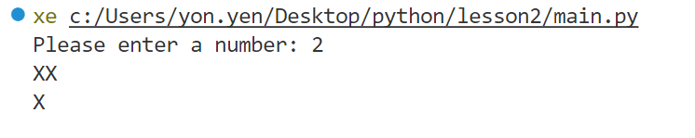

nb=int(input("please enter the nb"))

text=""

for n in range(nb):

    for m in range(nb-n):

        text=text+"x"

    text=text+"\n"

print(text)

1. Please

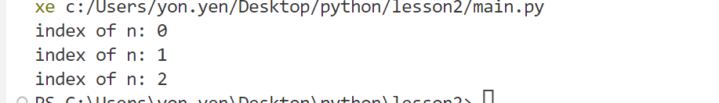

for n in range(3):

    print("indix of n:"+ str(n))

1. Please

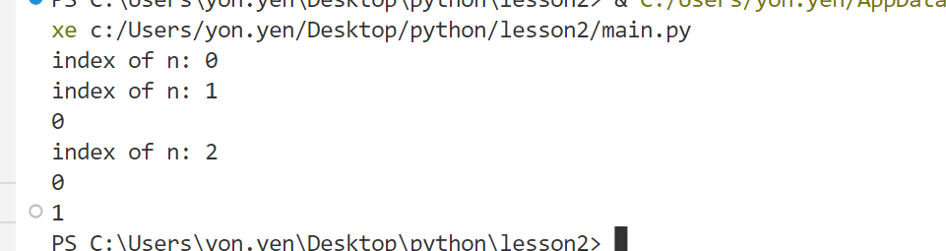

1. Please

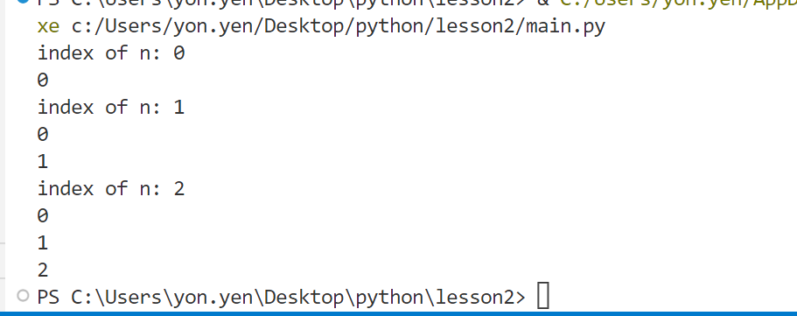

1. Please

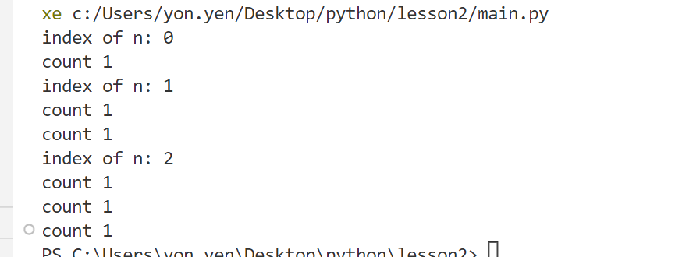

for n in range(3):

        print("index of n:"+str(n))

        for m in range(n+1):

                print("count1")

1. Please

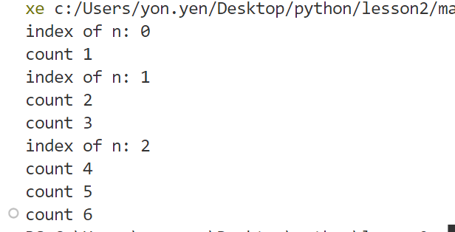

1. Please

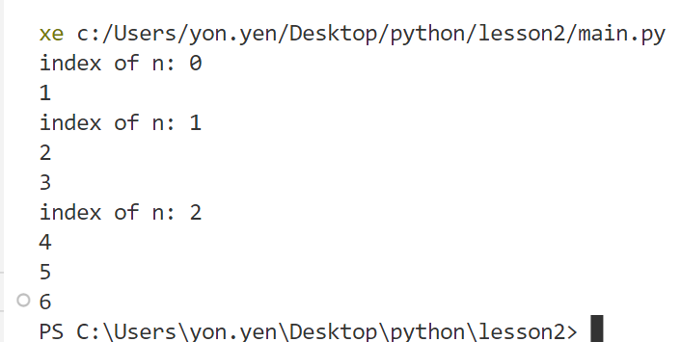

count=0

for n in range(3):

    print("index of n:"+str(n))

    for m in range(n+1):

        count=count+1

        print(count)

1. Please

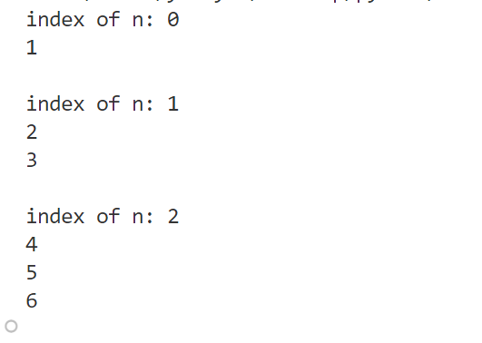

count=0

for n in range(3):

    print("index of n:"+str(n))

    for m in range(n+1):

        count=count+1

        print(count)

    print()

1. Please

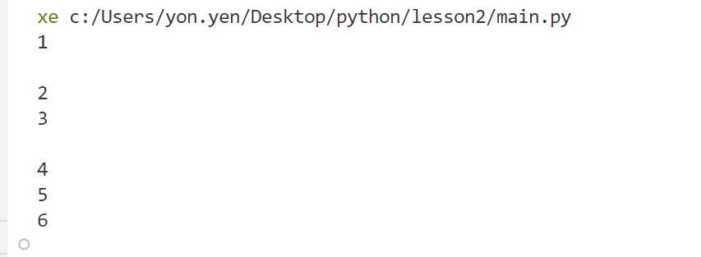

for n in range(3):

    for m in range(n+1):

        count=count+1

        print(count)

    print()

1. Please

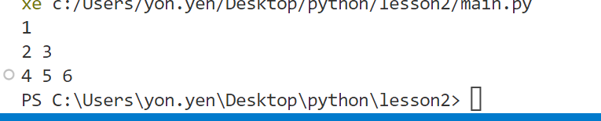

for n in range(3):

    for m in range(n+1):

        count=count+1

        print(count,*end*=" ")

    print()

1. Please

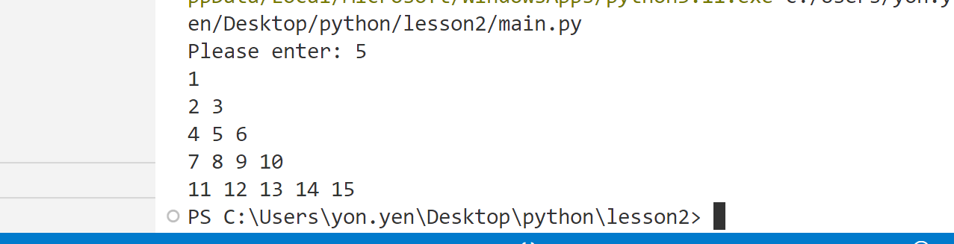

nb=int(input("enter the nb"))

count=0

for n in range(nb):

    for m in range(n+1):

        count=count+1

        print(count,*end*=" ")

    print()

1. Please

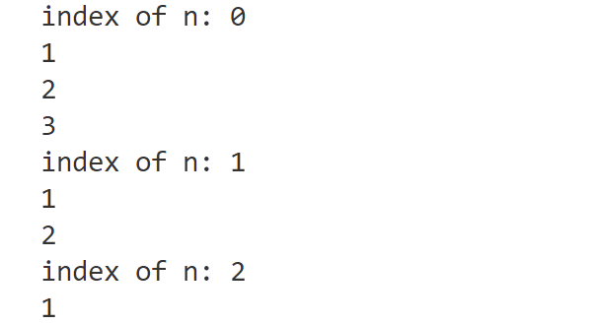

1. Please

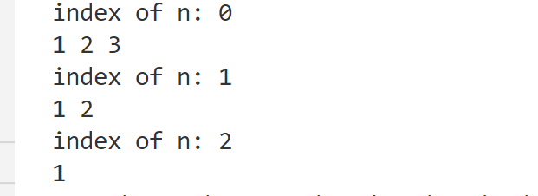

1. Please

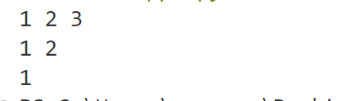

1. Please

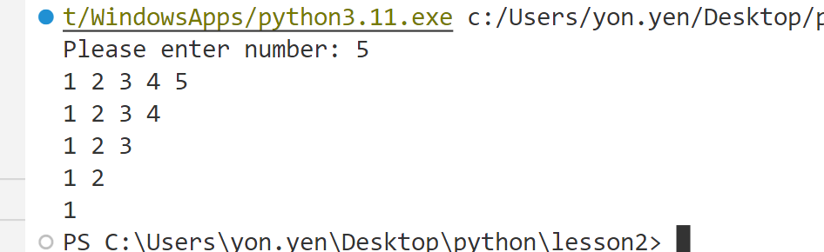

1. Please

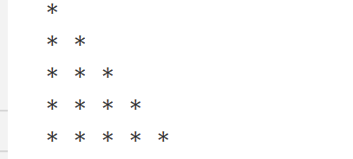

number = int(input("Please enter the number: "))

text =''

for n in range(number):

    for m in range(n+1):

        text = text + ' * '

    text = text+'\n'

print(text)

1. Please

